1. Response of damaged WTC7 after removing Column 79 from F5-F14
Composite beams:
Max overall deflection in east-west direction: 1.5” to the east
Max vertical direction: 7.15”
Concrete’s Young’s modulus: 3400000psi
Deflection scale factor: 20
No member yielding therefore progressive collapse would happen for the columns to buckle
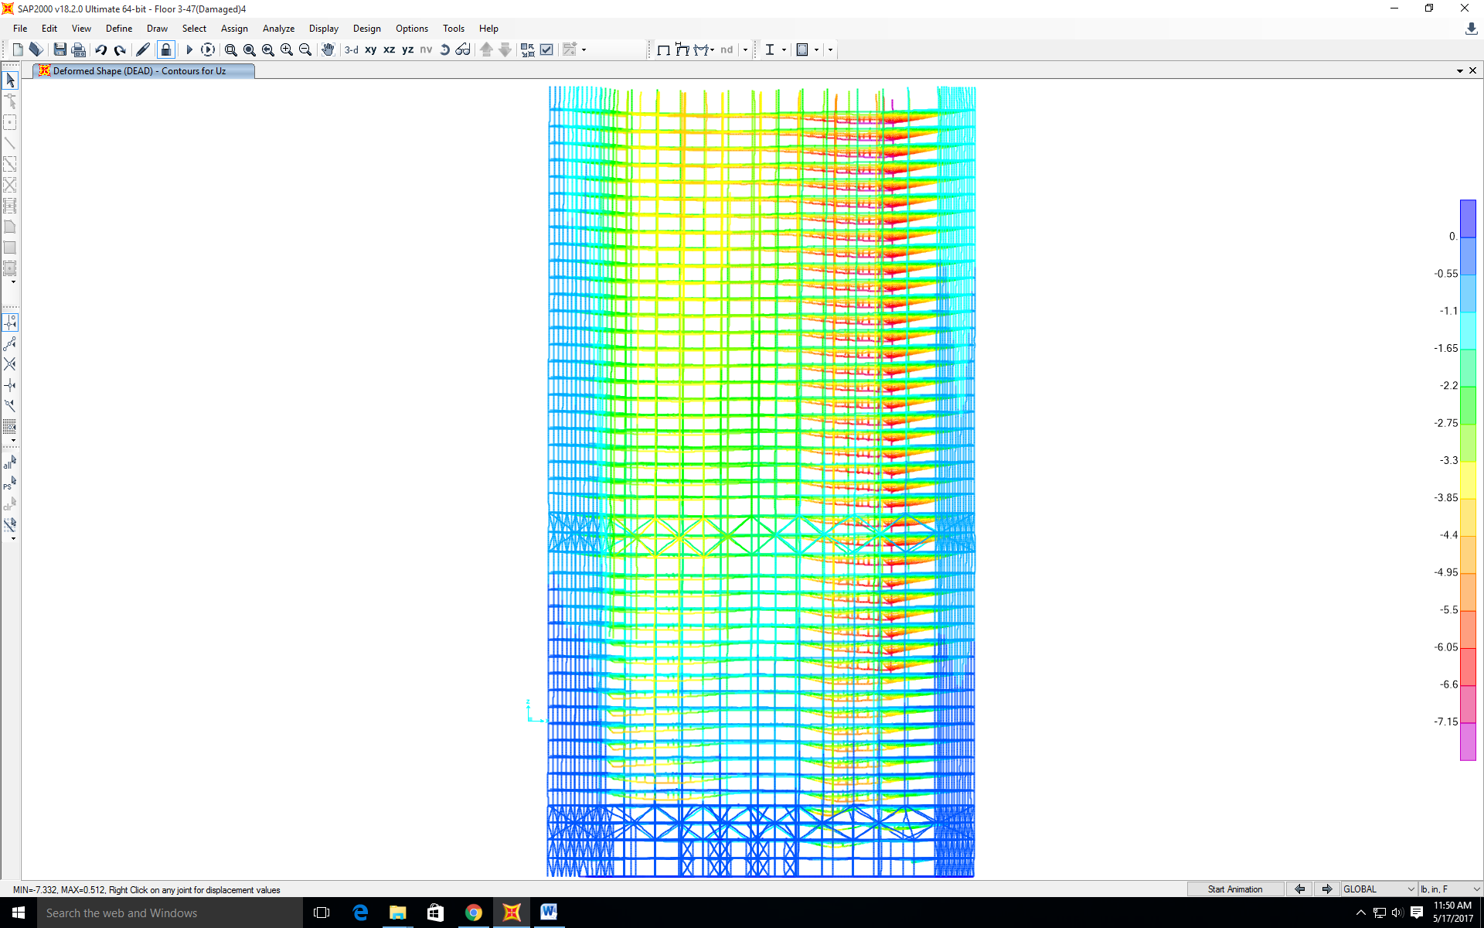

2. Deflection of WTC7 with non-composite beams behavior column 79 taken out from floor 21-floor7
Non-composite beams:
Max overall deflection in east-west direction: 37” to the east
Max vertical direction: 53”
Concrete’s Young’s modulus: 340psi
Deflection scale factor: 20
Lots of members yielding therefore progressive collapse would happen for the columns to buckle
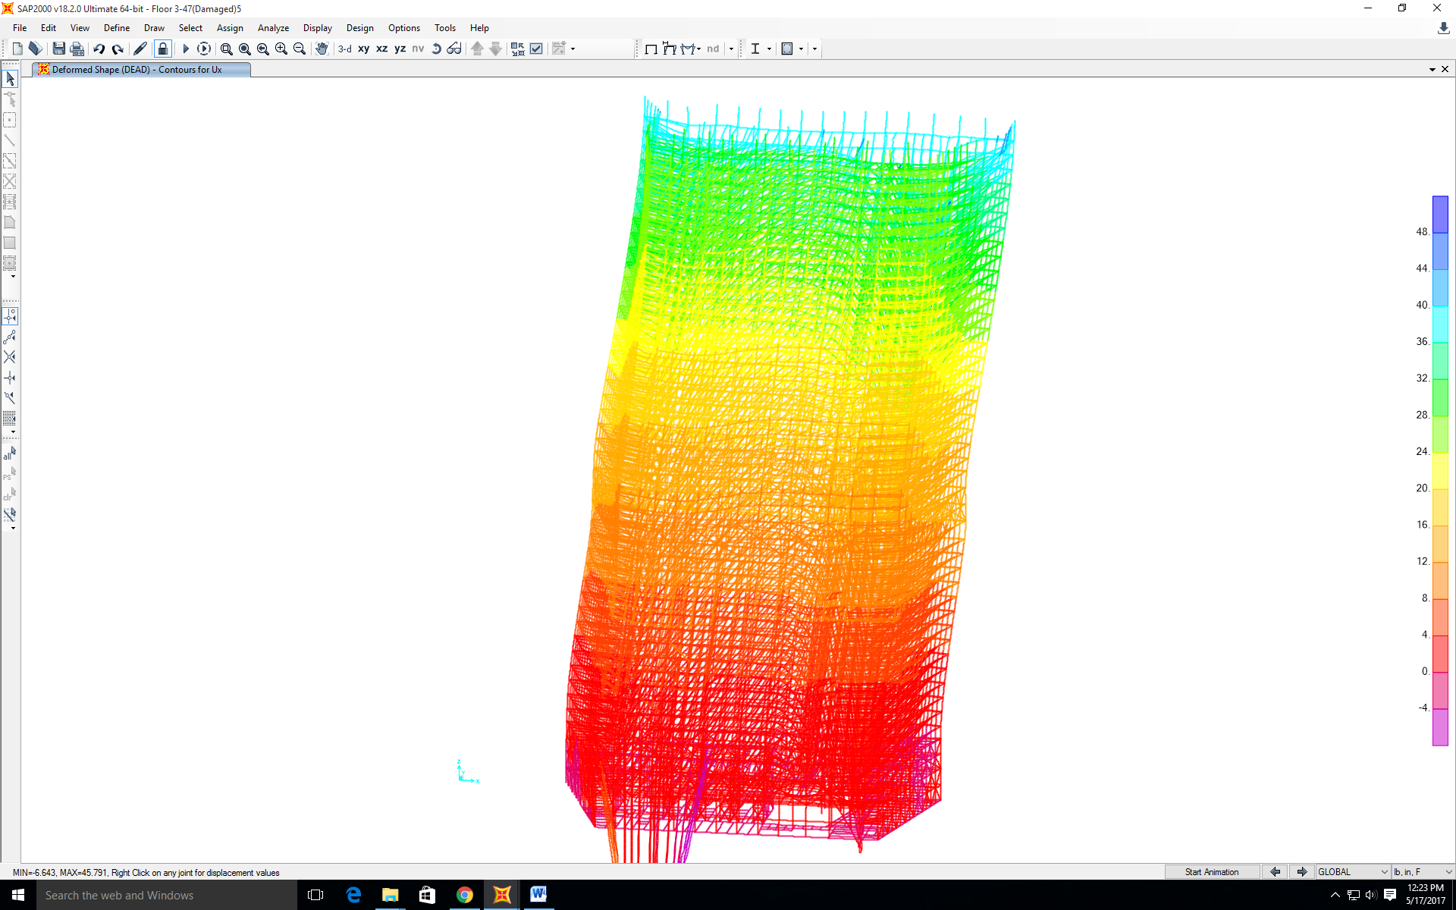

3. Core columns taken out from F14-F21 and the subsequent response of the whole WTC7; the damage caused by the debris of WTC1 also accounted for
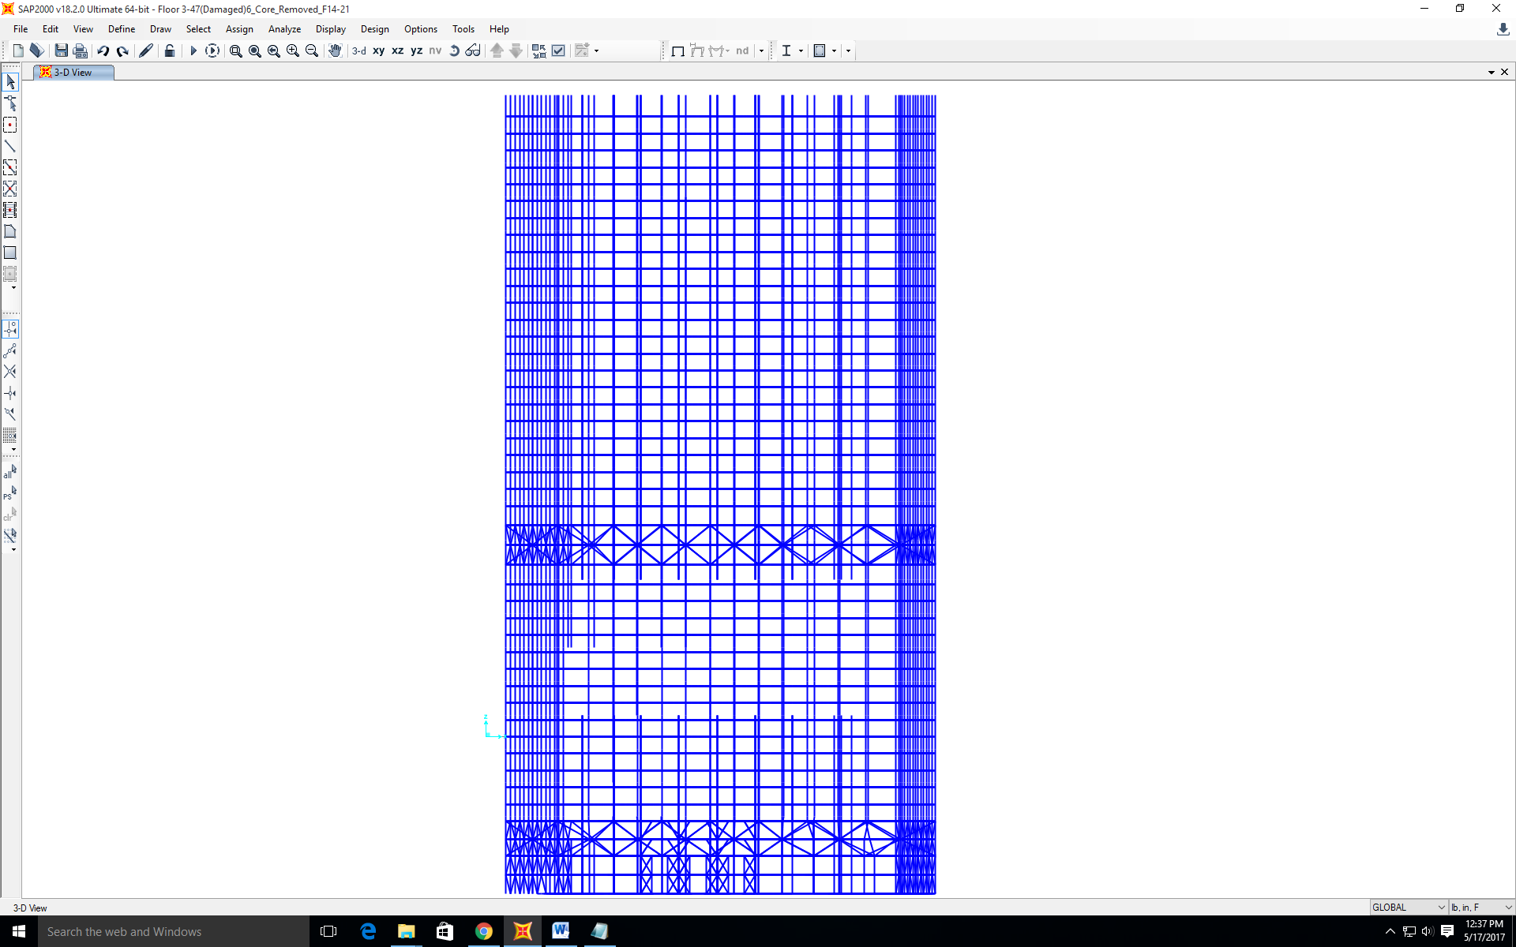

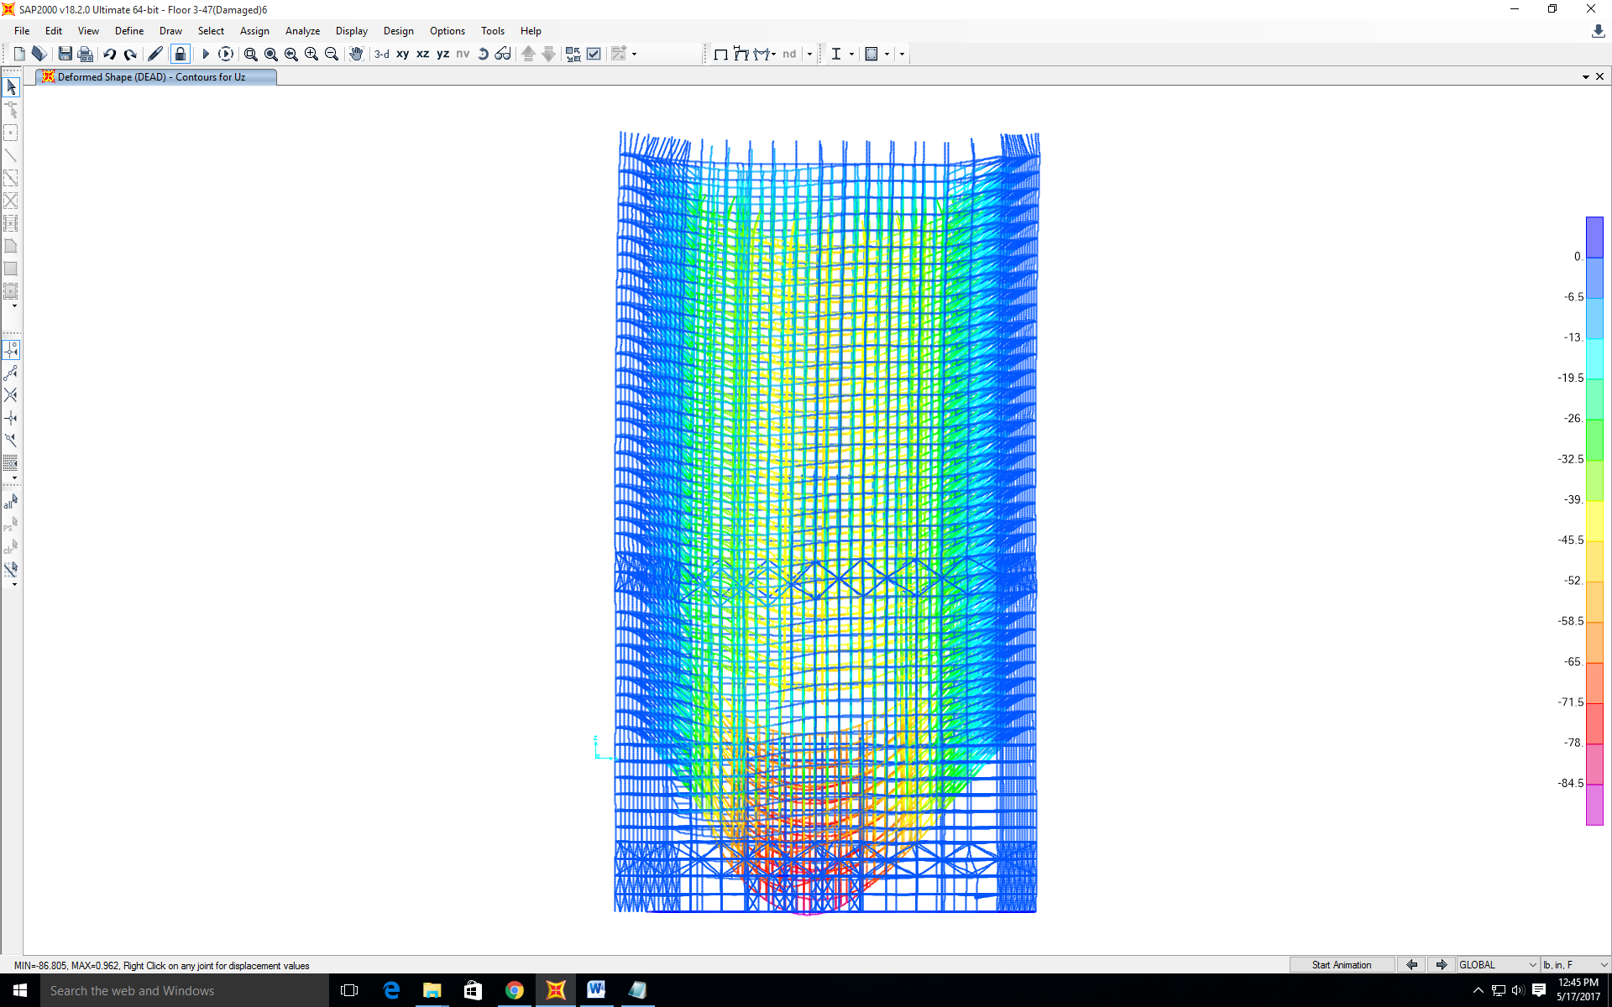
Composite beams:
Max overall deflection in east-west direction: 2.5” to the east
Max vertical direction: 86”
Concrete’s Young’s modulus: 3400000psi
Deflection scale factor: 20
Lots of members yielding therefore progressive collapse would happen for the columns to buckle

4. Core columns taken out from F7-F14 and the subsequent response of the whole WTC7; the damage caused by the debris of WTC1 also accounted for
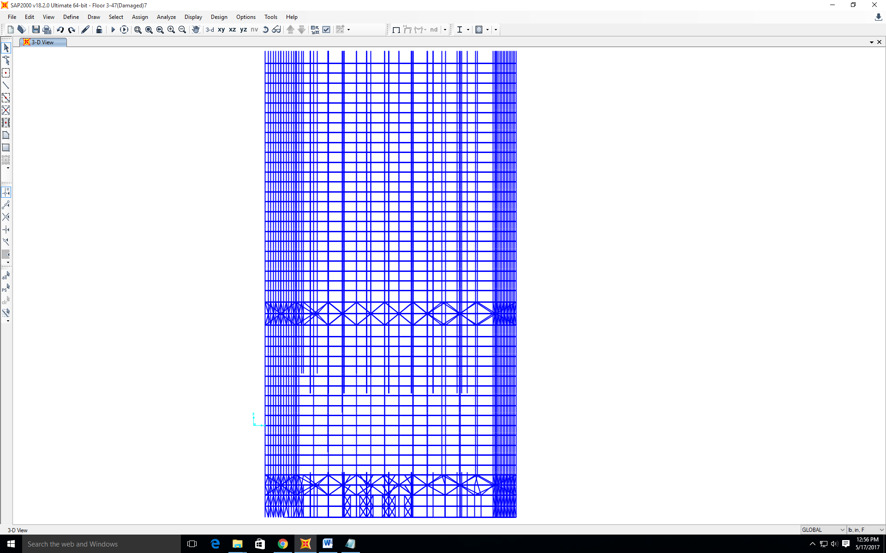

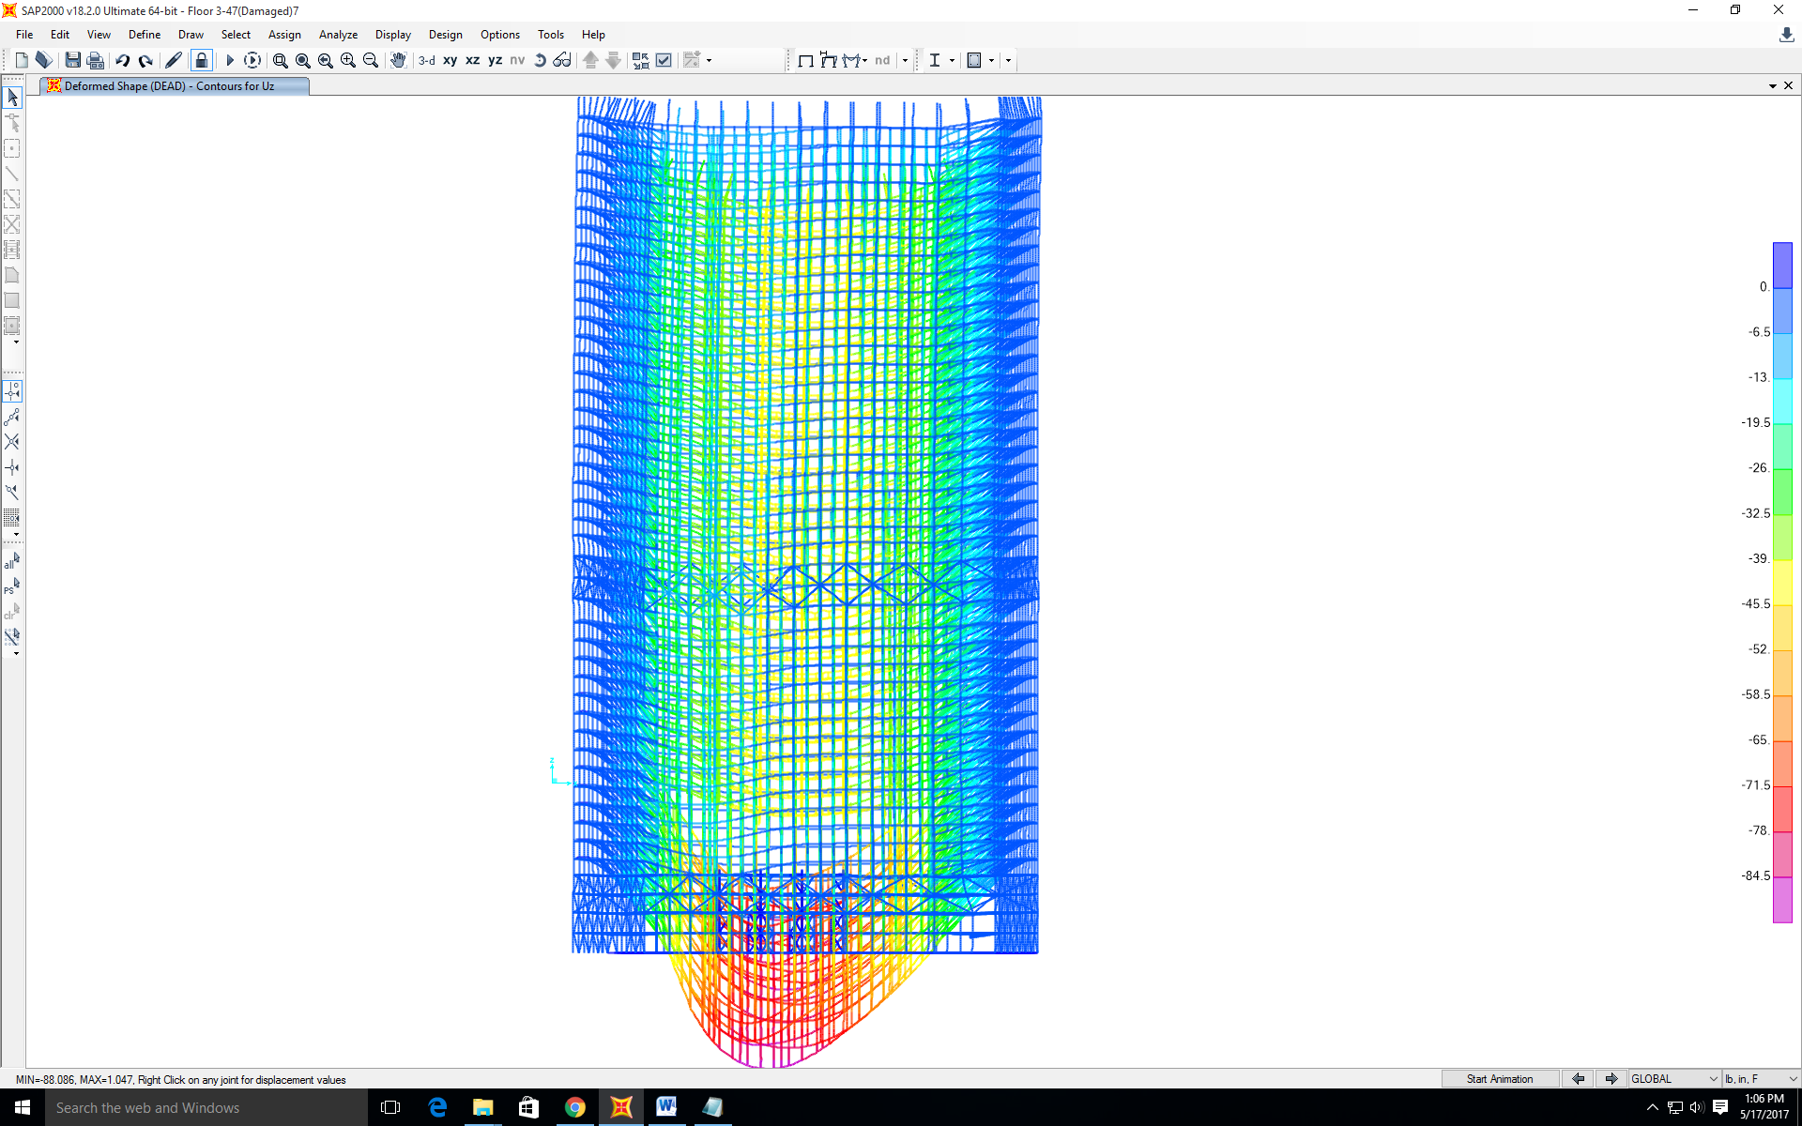
Composite beams:
Max overall deflection in east-west direction: 2.5” to the east
Max vertical direction: 88”
Concrete’s Young’s modulus: 3400000psi
Deflection scale factor: 20
Lots of members yielding therefore progressive collapse would happen for the columns to buckle

5. Soften the steel member caused by elevated temperature and see what it takes to fail the building
To be discussed
